**QUESTION 1:**

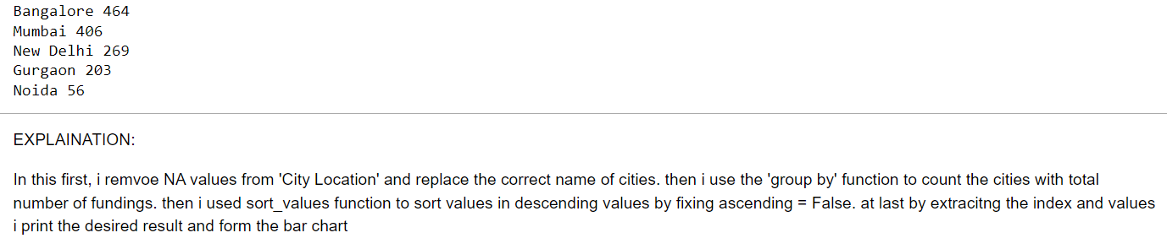

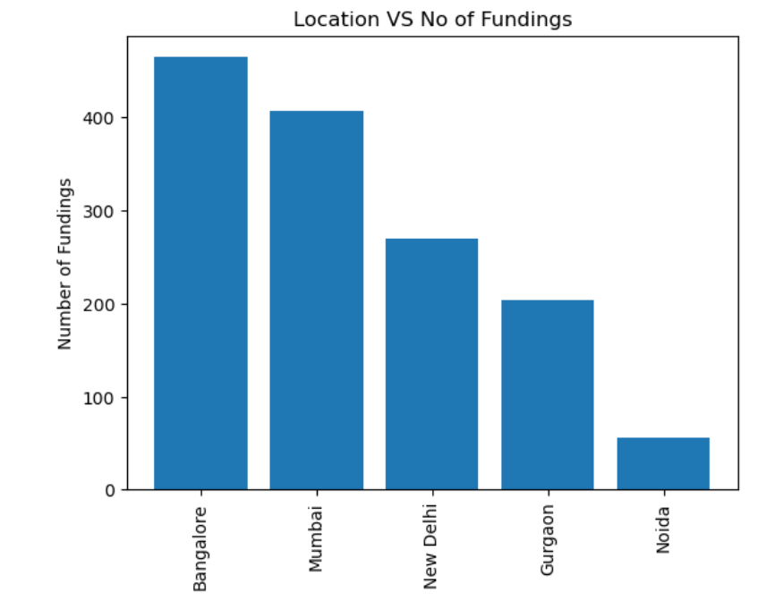

**QUESTION -2:**

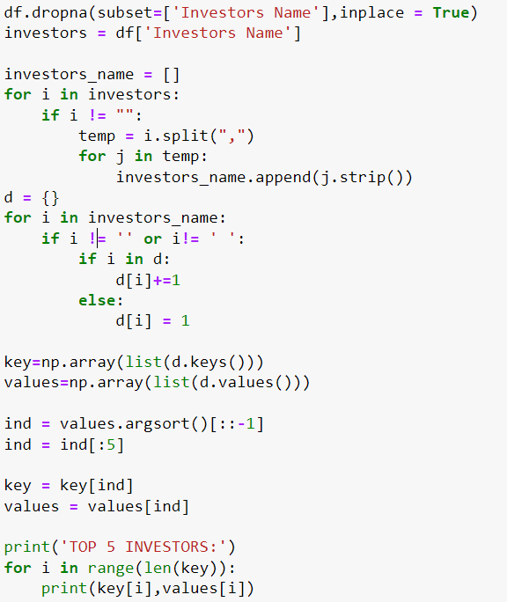

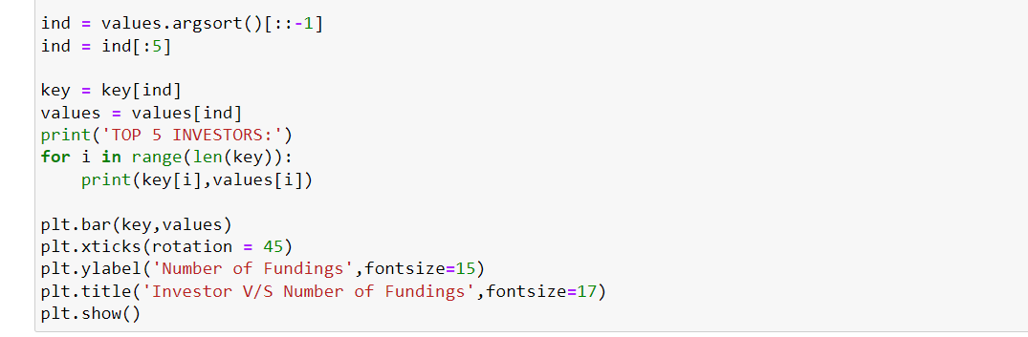

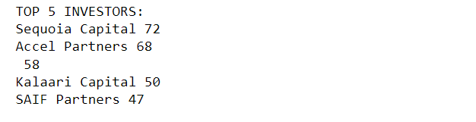

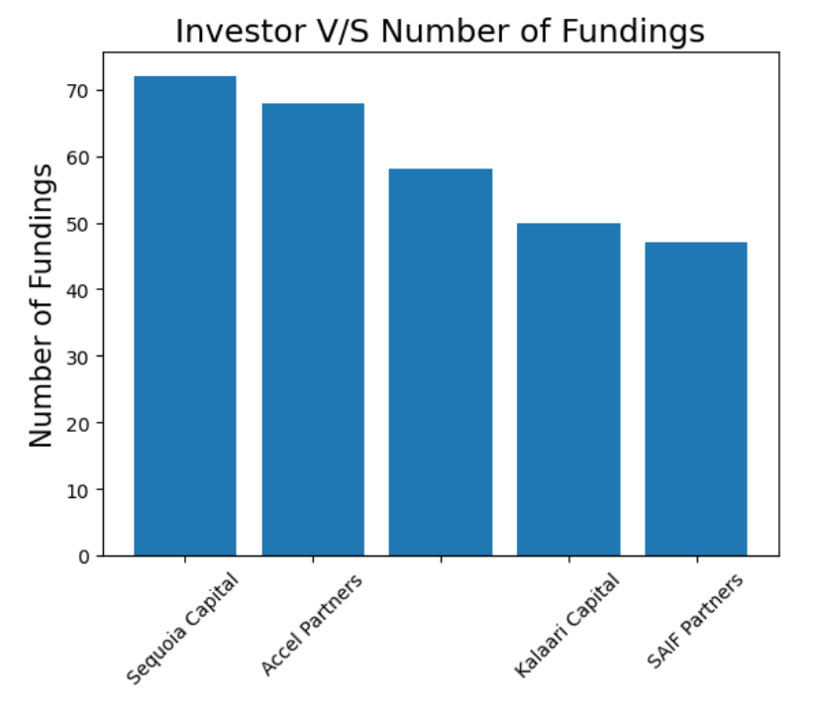

**EXPLAINATION:**

In this code, first I removed all the NA values from Investor Name column. After that, I formed the list of investors by splitting the by ” , ” because it can possible that multiple investors invest in same company. So, to count all the investors individual I formed the list. After, that I formed dictionary to form the key and values for individual customers. Then I formed the NumPy arrays for both key and values. Then I sort the values to get desired values and print the required result.

**QUESTION 3:**

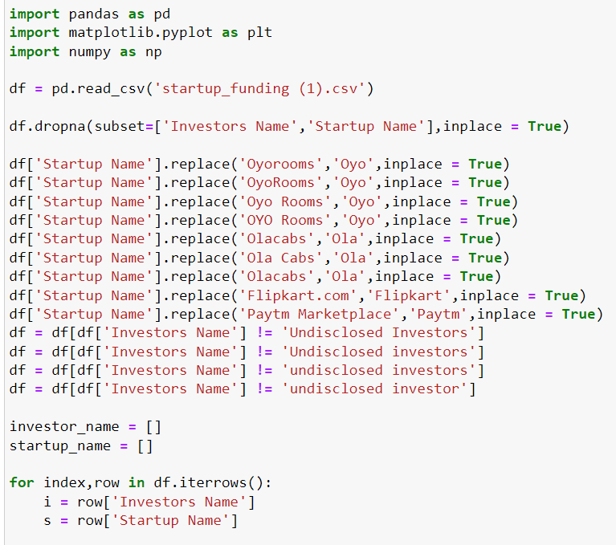

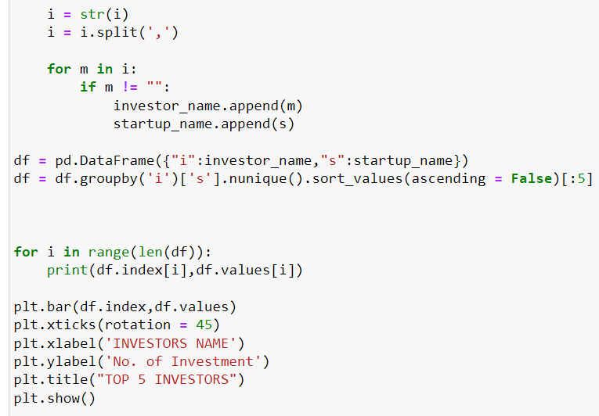

**OUTPUT:**

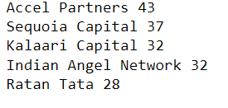

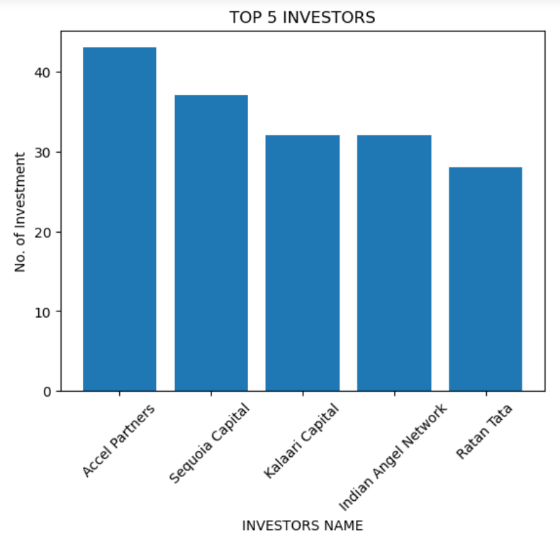

**EXPLAINATION:**

First, I removed the NA values from investor name, startup name column. After that I corrected all the startup names and investor names.

Then I form the two separate lists for the individual values from investor name and startup name as there are multiple investors in 1 company only.  
then converted those lists into data frame and group by both values to get the unique investment for the individual startup.

**QUESTION 4:**

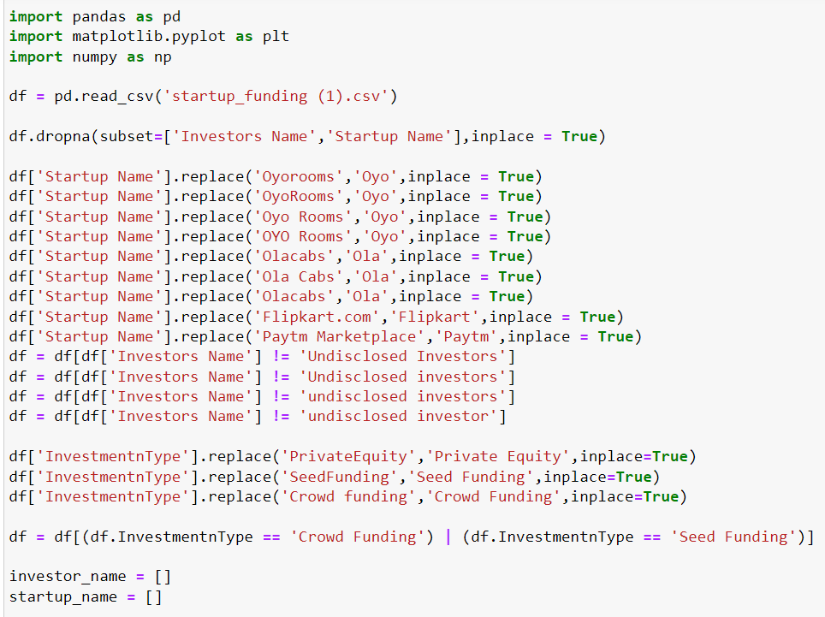

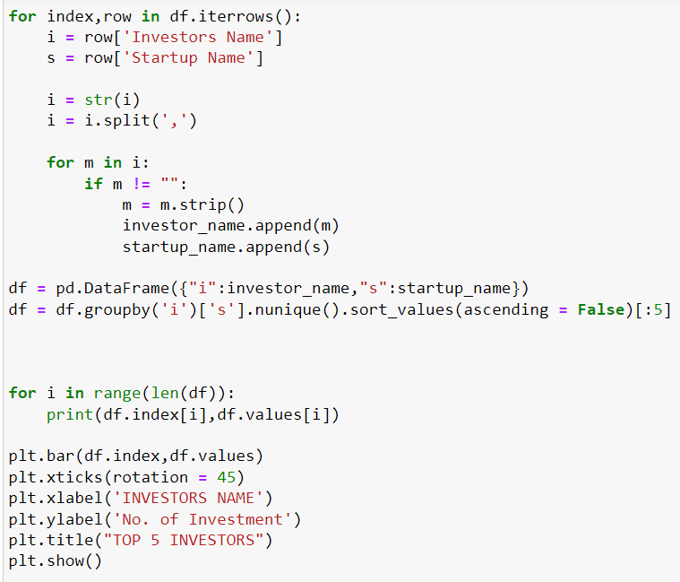

**OUTPUT:**

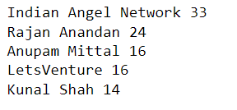

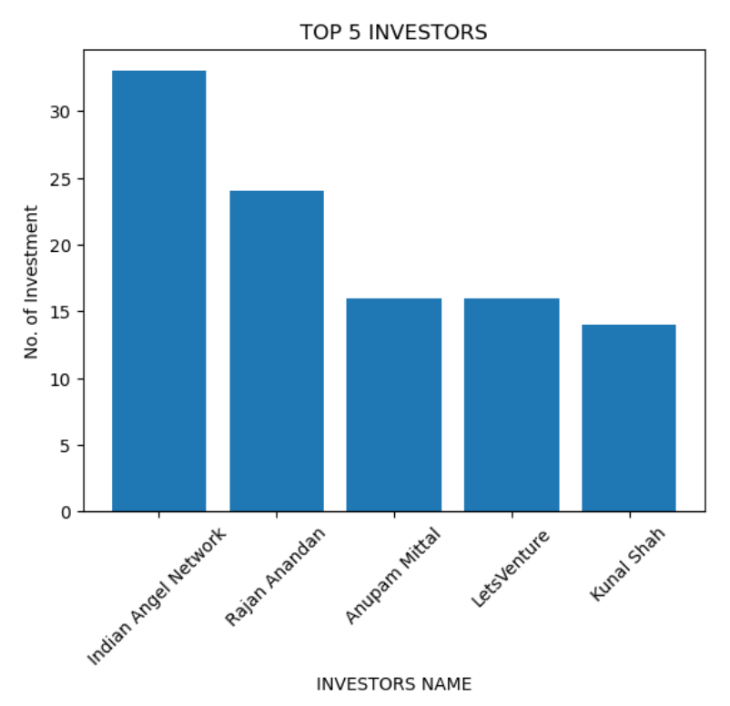

**EXPLAINATION:**

The idea of solving this problem is same as the question 3. I just corrected the names of Investment Type and filter out the data frame by selecting the crowd funding and seed funding rows as this type of investment are priority only.

**QUESTION 5:**

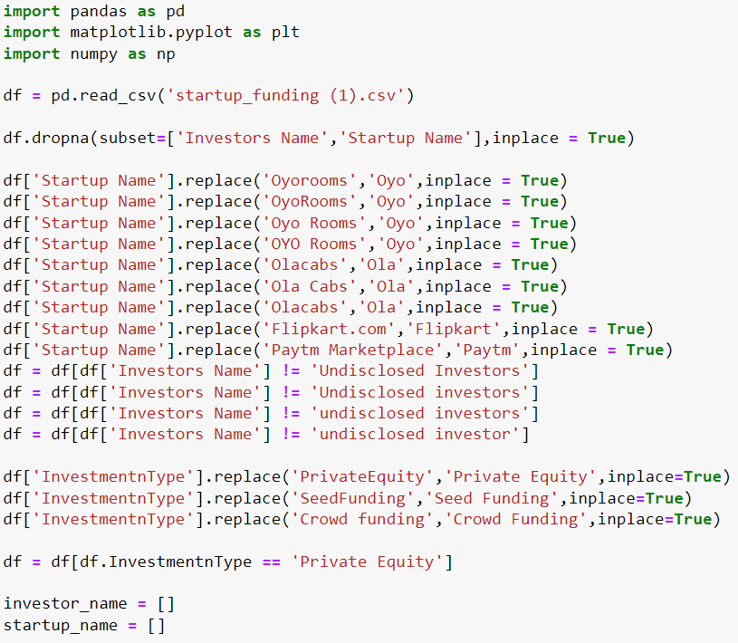

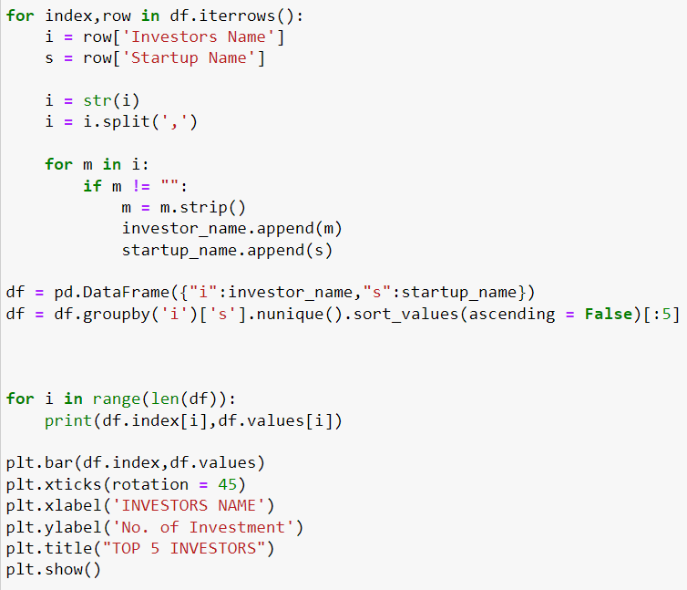

**OUTPUT:**

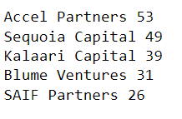

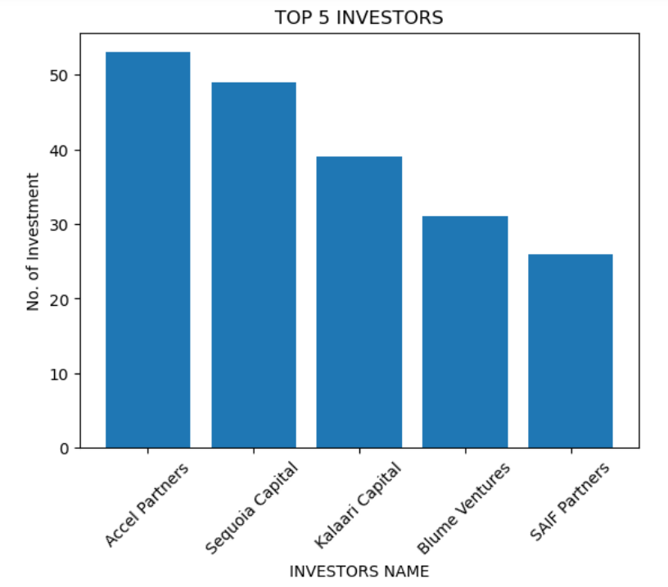

**EXPLAINATION:**

Again, this solution is same as the question 4. This time I filtered out the rows for the Private Equity instead of crowd funding and seed funding.